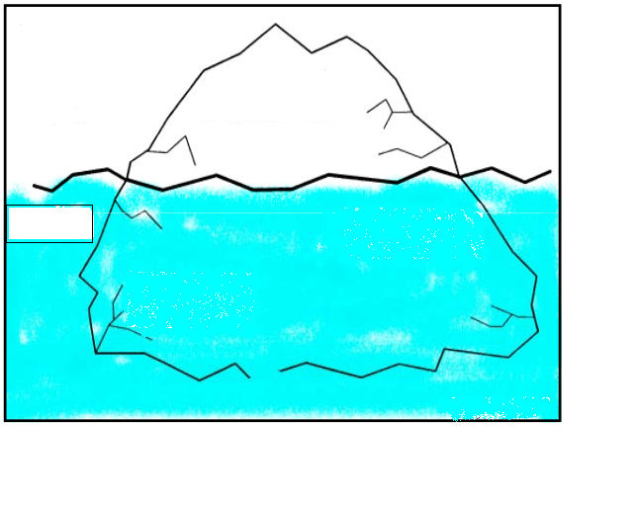
What?
Why?
The Iceberg Metaphor

